

**Applecross Senior High School**

**/25**

**Year 12 Physics**

**Motion and Torque Problem Sets Validation Test**

Name: ____________________________

1. A 1150 kg car follows a circular path around a roundabout of radius 19.0 m at a constant speed of 22.0 km h-1.  
   (a) Is the car accelerating? Explain. (1 mark)

____________________________________________________________________________________________________________

____________________________________________________________________________________________________________

(b) Find the average force provided by the friction between the tyres and the road to maintain this

circular path. (2 marks)

(c) At what angle would the curved road need to be banked for there to be no need to rely on friction

to maintain the circular path? (2 marks)

1. Susanna has a mass of 52 kg and swings on a 4.5 m long maypole chain with enough speed to swing in a circle of radius 2.7 m.
2. Use the diagram right to draw a free body diagram showing all the forces acting on Susanna. (1 mark)
3. Calculate the tension in the chain. (2 marks)

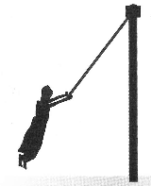

Question 2. continued

1. Calculate Susanna’s period of revolution. (2 marks)
2. A stone of mass 1.50 kg is whirled in a vertical circle at the end of a 2.00 m length of string.

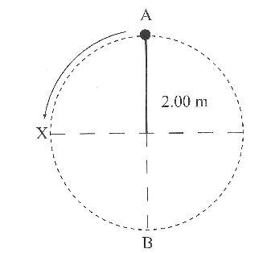

(a) The stone passes through point X at a speed of 12.4 m s-1. Calculate its speed at points A and B. (2 marks)

(b) Calculate the tension in the string at points A and B. (2 marks)

(c) At which point, A, B or X, is the string most likely to break? Explain your answer.

(2 marks)

1. The gravitational force acting on the space shuttle at sea level is F.  
   a) At what height above the Earth's surface would the gravitational force acting on the shuttle be ⅓F?

(2 marks)

Question 4. continued

b) If the shuttle is in orbit around the Earth at a height of 720 km above the Earth's surface.

What is the gravitational acceleration the shuttle experiences? (2 marks)

c) What orbital speed did the shuttle have to keep it in this orbit? (2 marks)

1. What is the height above the Earth's surface of a communications satellite if it always orbits above a particular spot on the equator? (3 marks)